API automation using TestNG

Scenario :

1. Use post method and login to API URL
2. Capture the status code and repones body

Project folder structure

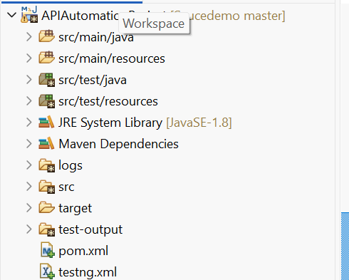

Dependency added to POM xml file

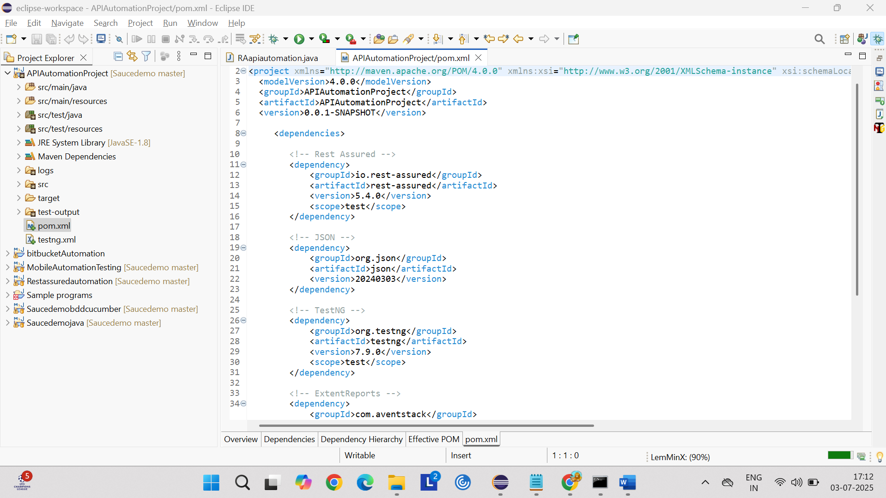

Test class where the project is written and executed with 2 methods

1. Positive
2. Negative

API URL use: <https://reqres.in/api/login>

Positive scenario request payload

{ "email": "eve.holt@reqres.in", "password": "cityslicka"}

Negative scenario request payload

{ "email": "test@gmail.com", "password": "test"}

Negative scenario request with missing password

Tests package

LoginAPITest.java

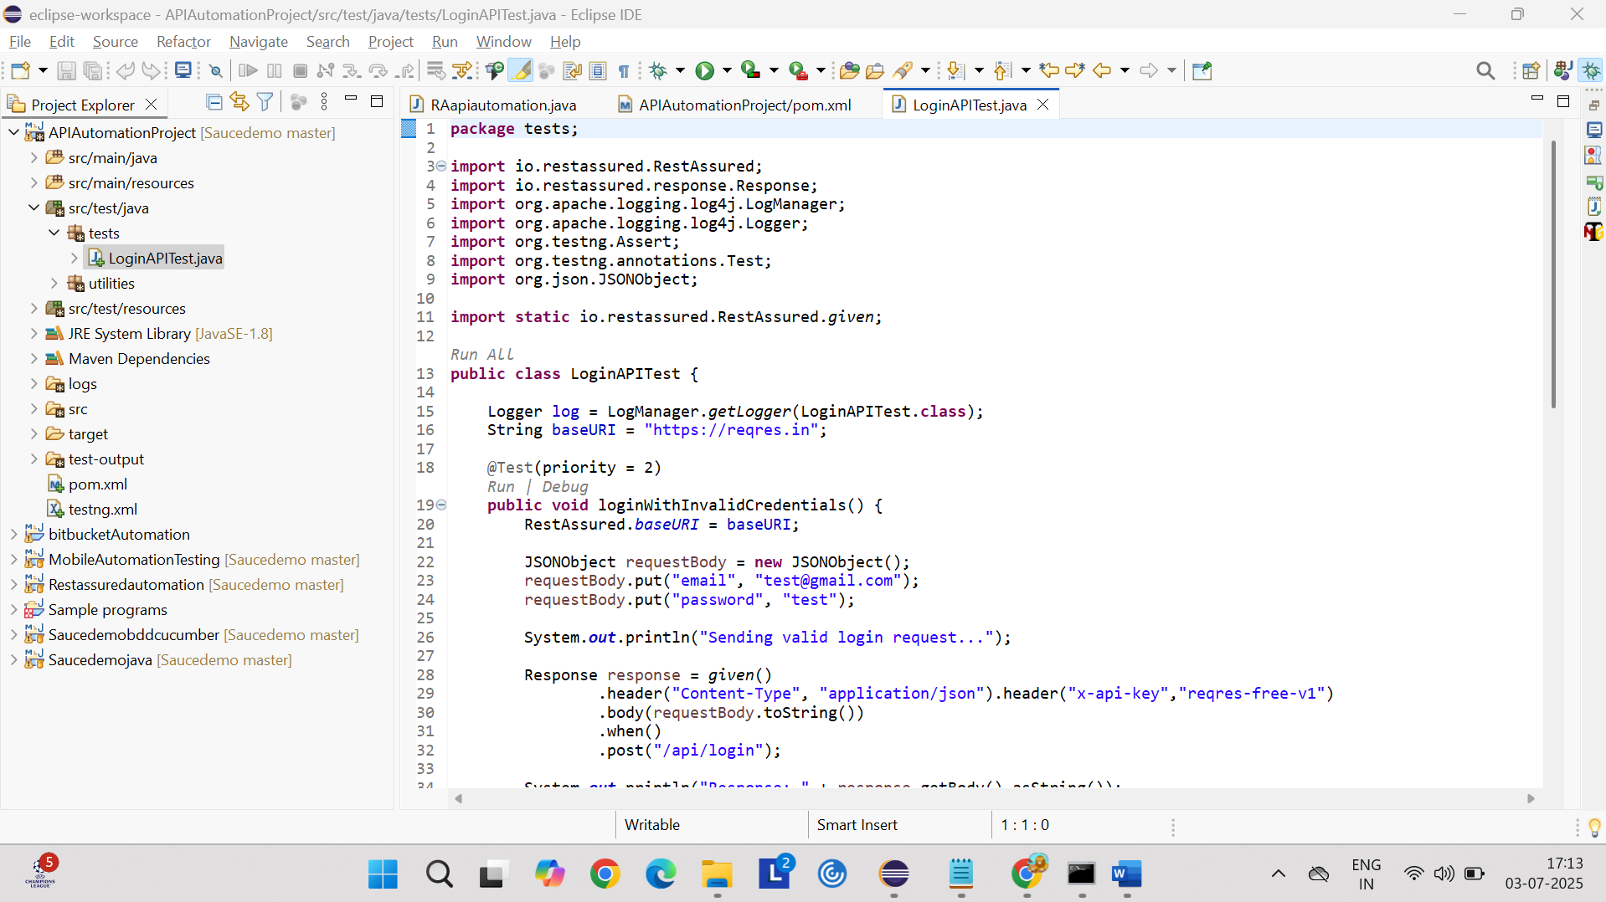

Utilities package

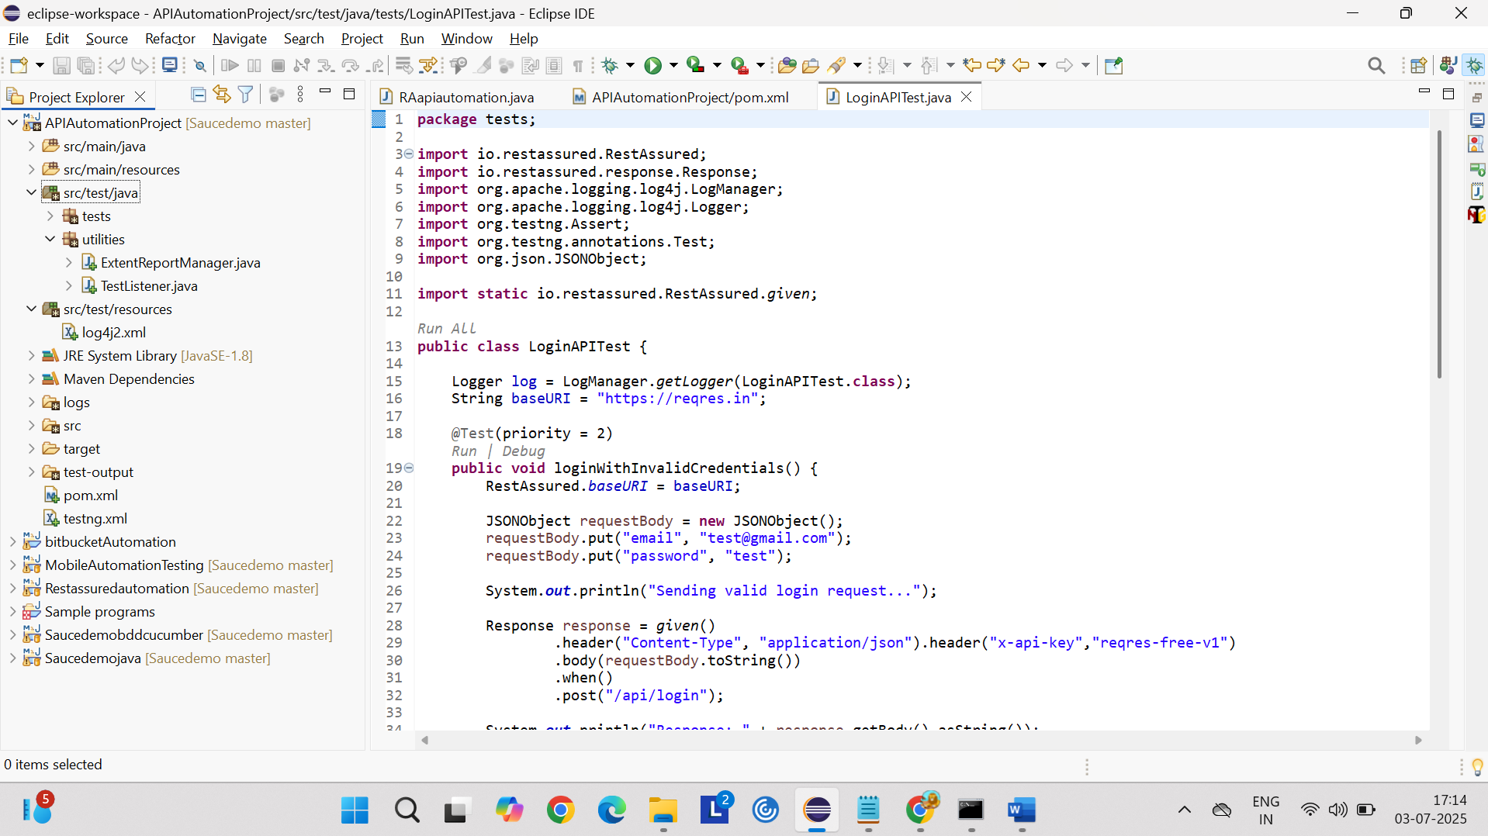

Utilities

ExtendReportManager.java

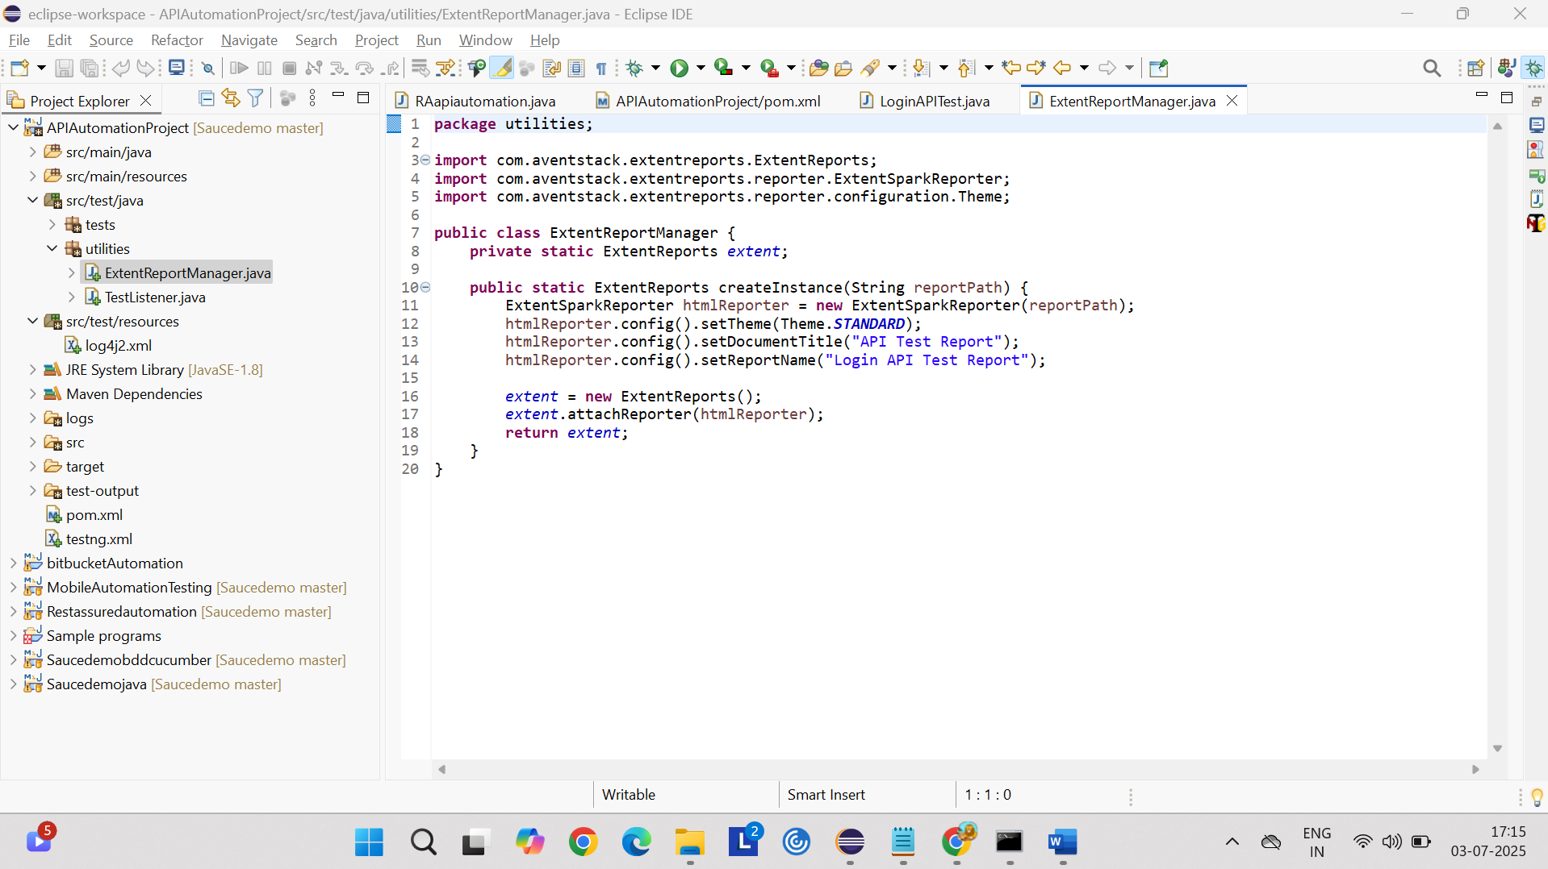

TestListener.java

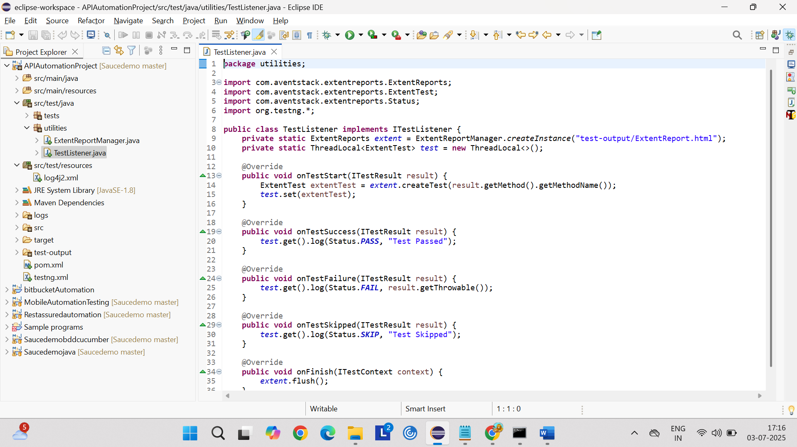

Testng.xml

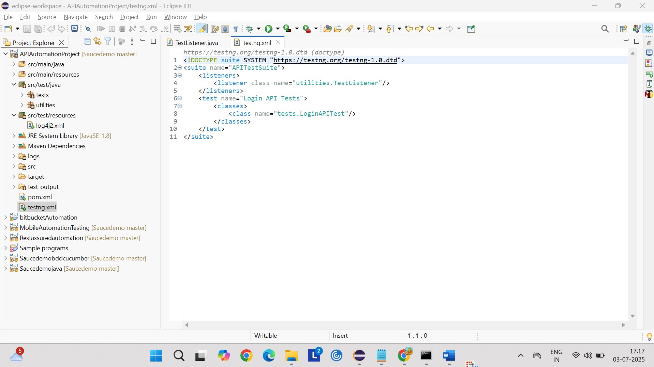

Log4j2.xml

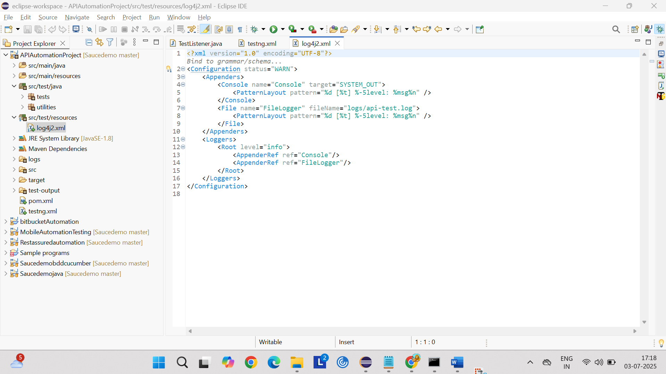

Recording for Executing the test in the eclipse



Console output screen shot

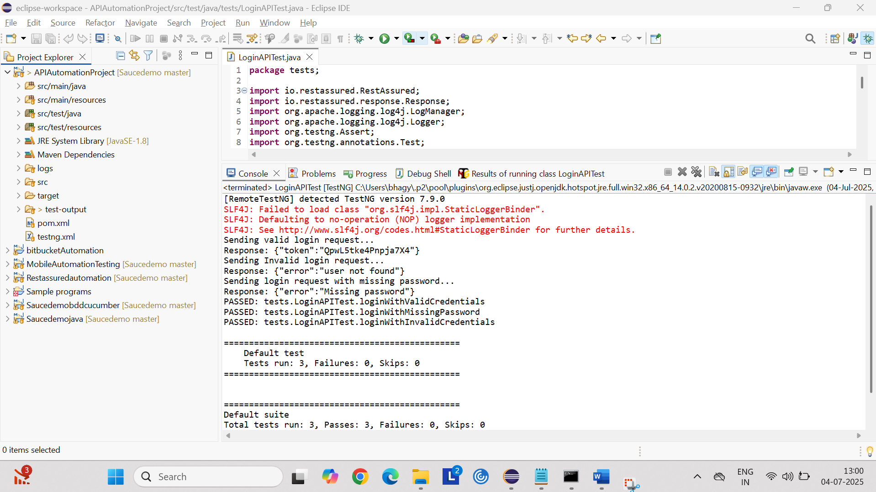

Jenkins configuration

Step1: download Jenkins war file

Step2: go to command prompt

Step3: move the locator to Jenkins war file path

Step4: java -jar Jenkins.war give this commend and click enter

Step5: once we Jenkins up and running text is displayed in the cmd

Step6: open <http://localhost:8080/> in browser and enter ur credentials and set up the project and configure with path

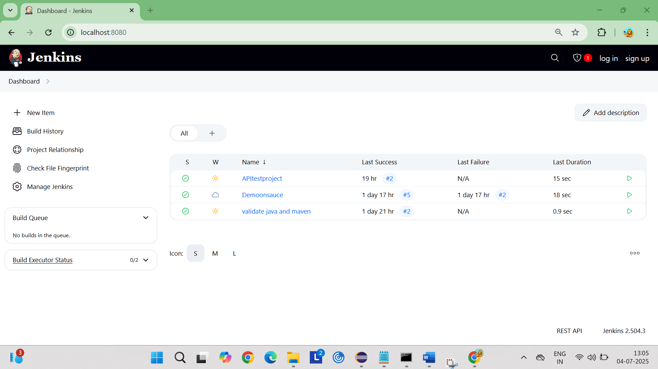

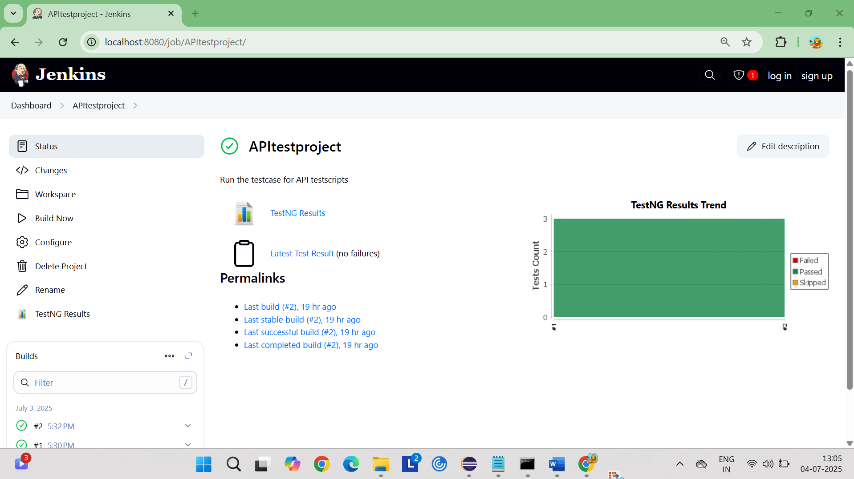

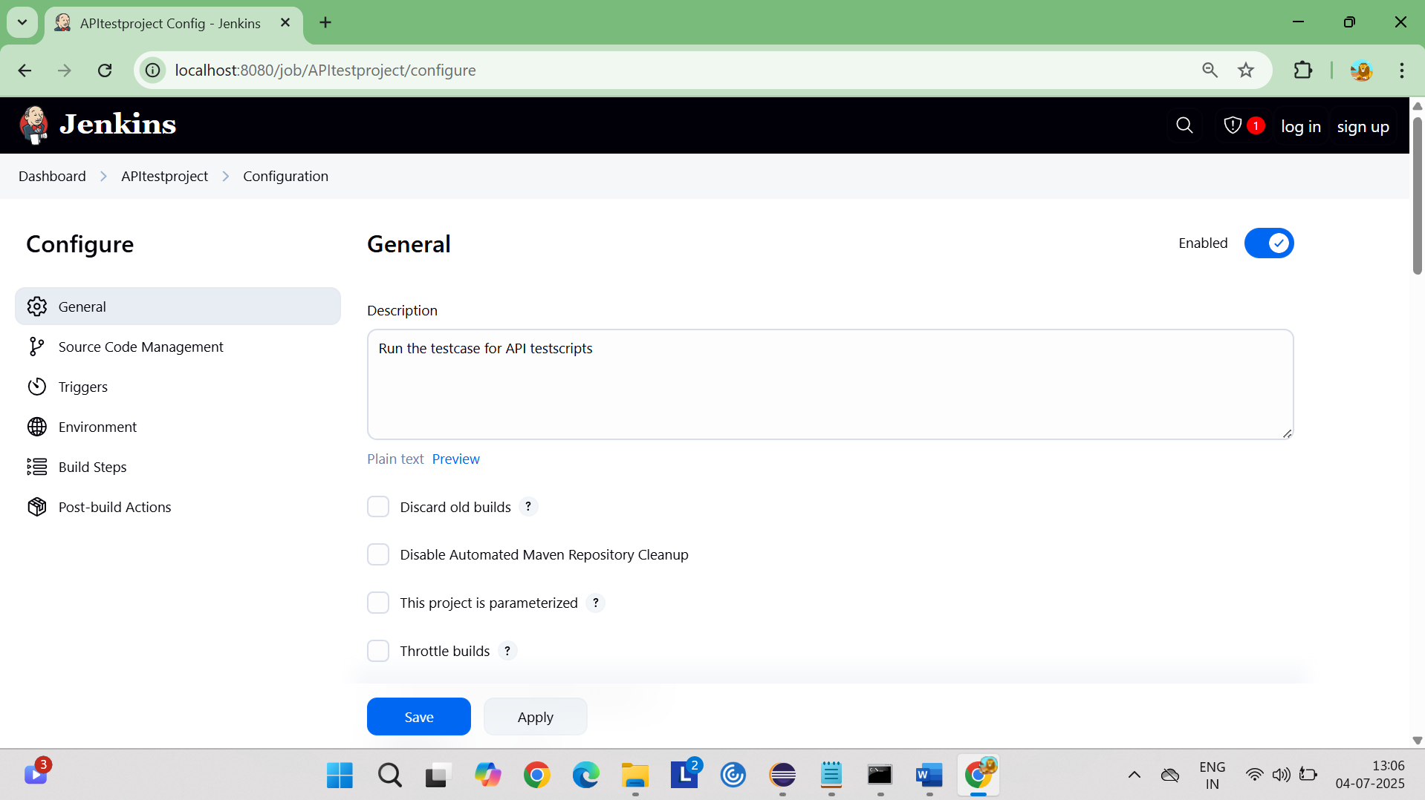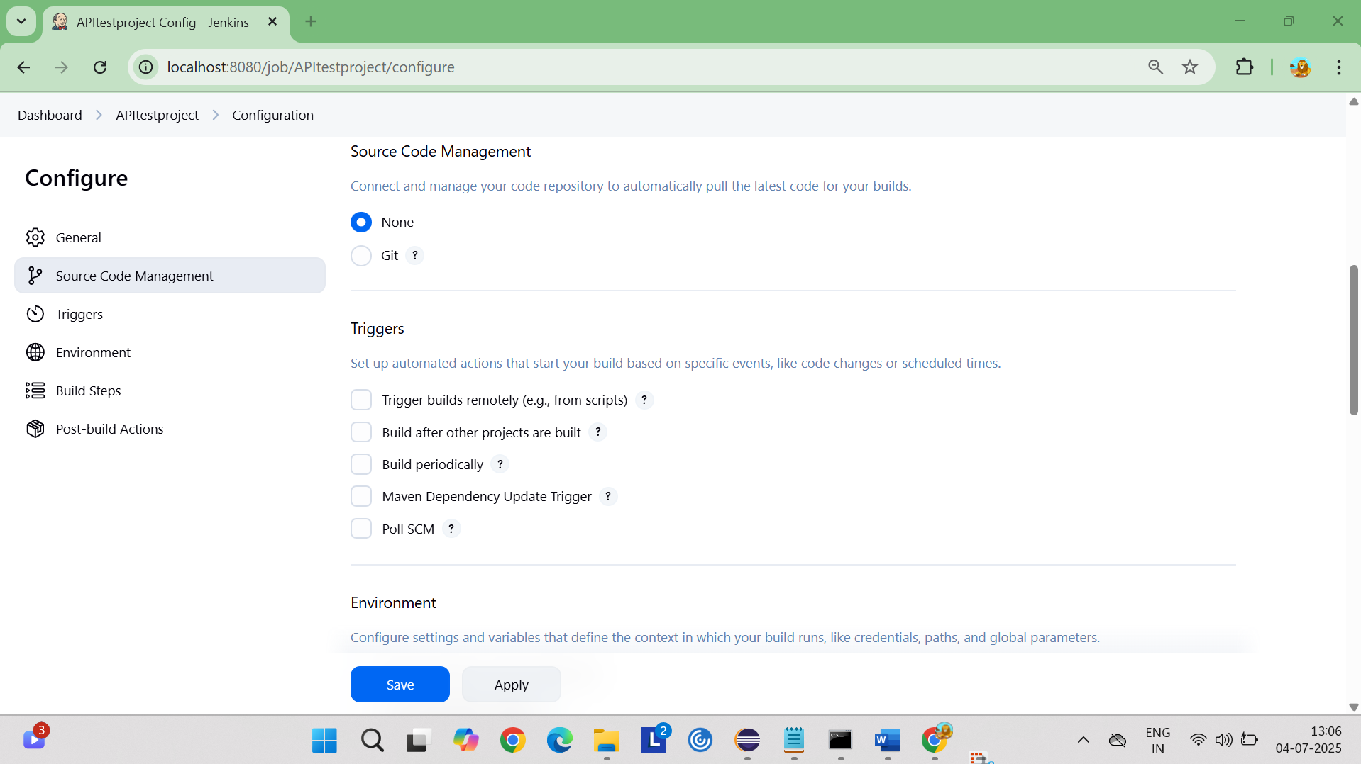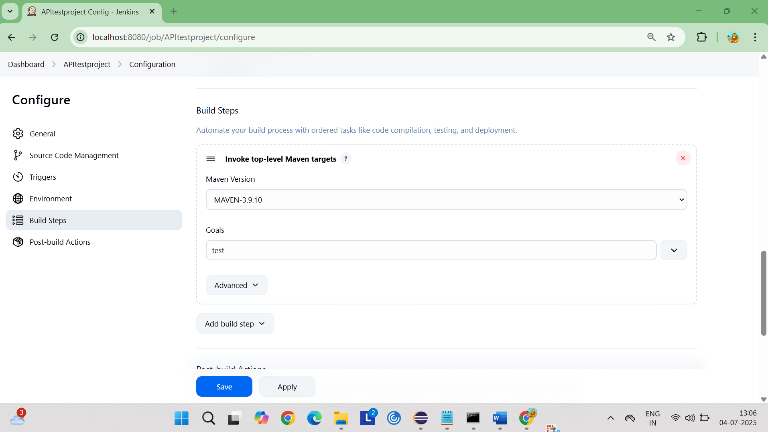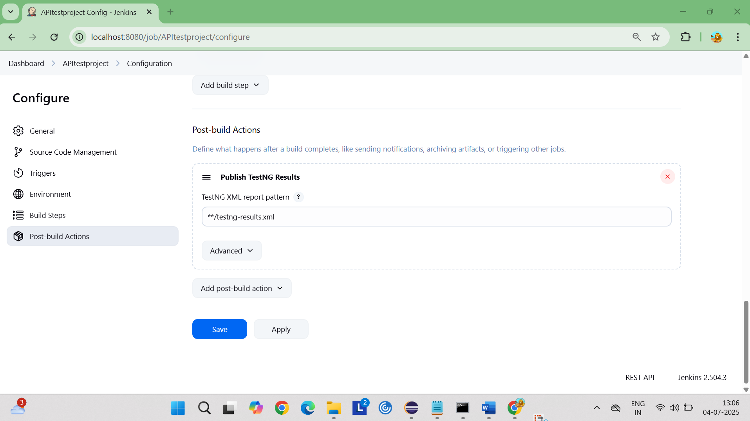

Recording for Executing the test in the Jenkins

